Rolland, Geoff

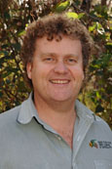

Graduated from Dwellingup cadet school in 1987. Appointed forest guard. Worked for Department of CALM. Forestry Manager with Albany Plantation Forest Company 2013.

